**1. Cauchy–Schwarz Inequality**

For any two real (or complex) sequences (or vectors)

a=(a1​,a2​,…,an​), b=(b1​,b2​,…,bn​)

the Cauchy–Schwarz inequality states:

This inequality is fundamental in linear algebra, functional analysis, and probability theory. In statistics, it guarantees that the **correlation coefficient**

always satisfies ∣r∣≤1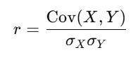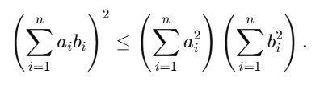.

### ****Proof (Quadratic Function Method)****

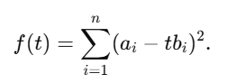We construct a quadratic function that must always be nonnegative:

1. **Nonnegativity**:  
   Since squares are always nonnegative, we have f(t)≥ 0 for all real t.
2. 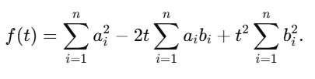**Expand the expression**:

This is a quadratic in t:

With

1. **Discriminant condition**:  
   For f(t) to be nonnegative for all t, the discriminant must satisfy:

which simplifies to

1. 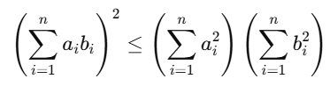**Conclusion**:
2. **Equality condition**:  
   Equality holds if and only if there exists a constant λ such that

a*i*=λb*i* for all *i*,

i.e., when the vectors a and b are **linearly dependent**.

### ****Interpretation in Statistics****

If we let and, then the inequality directly shows that the

**Pearson correlation coefficient** satisfies:



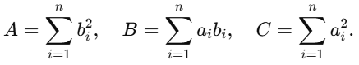Thus, Cauchy–Schwarz is the mathematical foundation behind why correlation must always lie between −1 and +1.

## ****2. Concepts of Independence and Uncorrelation****

### ****Independence****

Two random variables X and Y are **independent** if knowledge of one gives no information about the other. Formally, for all measurable sets A,B:

* This is a **strong condition**: it means that the joint distribution factors into the product of the marginals.
* Independence eliminates **all forms of dependence**—both linear and nonlinear.

### ****Uncorrelation****

Two random variables are **uncorrelated** if their covariance is zero:

* This condition only rules out **linear relationships**.
* However, X and Y may still be related **nonlinearly**.

### ****Key Differences****

* **Strength**:
  + Independence ⟹ uncorrelation (if variances are finite).
  + Uncorrelation ⟹ independence.
* **Implications**:
  + Independence guarantees that **all possible dependencies vanish**.
  + Uncorrelation only ensures the absence of **linear dependence**.

**Example**:  
Let X∼Uniform[−1,1], and define Y=X2.

* Then and Cov (X,Y)=0.
* So X and Y are **uncorrelated**, but they are clearly **dependent** (since knowing X determines Y).

### ****Other Measures of Dependence****

Since uncorrelation is limited, other measures are often used:

* **Mutual Information (MI):**  
  Captures the overall dependency (linear and nonlinear). *MI(X;Y)= 0* if and only if X and Y are independent.
* **Distance Correlation (dCor):**  
  Detects both linear and nonlinear dependencies. It is zero if and only if X and Y are independent.

### ****Summary****

1. **Cauchy–Schwarz Inequality**:
   * Proved by constructing a nonnegative quadratic function.
   * Ensures that correlation coefficients always lie in [−1,1].
   * Equality holds only when the two vectors are proportional.
2. **Independence vs. Uncorrelation**:
   * Independence is much stronger, eliminating **all** dependencies.
   * Uncorrelation only eliminates **linear dependence**.
   * Example: X uniform on [−1,1], Y= X2: uncorrelated but not independent.
   * More general dependence can be measured using **mutual information** and **distance correlation.**